Link to Github: <https://github.com/VUGANEZAPATRICE/ihuzoNewAssignment>

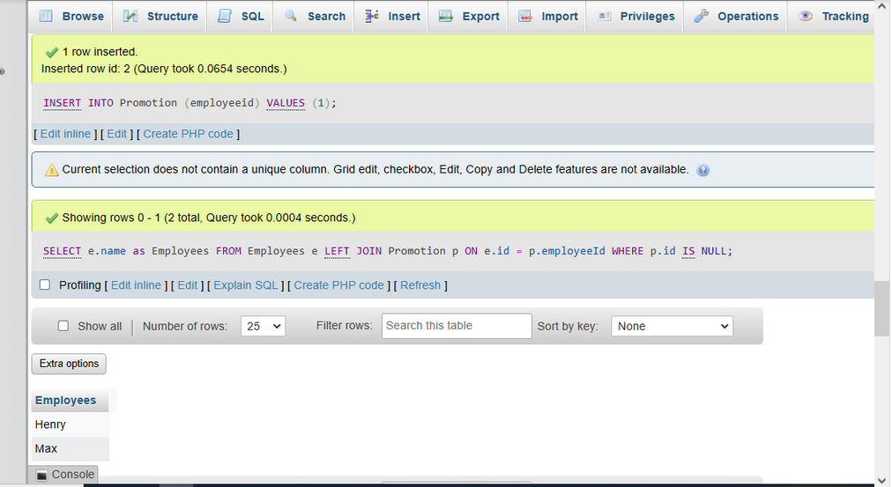

**MYSQL**

CREATE DATABASE Assign_database;

USE Assign_database;

CREATE TABLE employees (

  id INT AUTO_INCREMENT PRIMARY KEY,

  name VARCHAR(255)

);

CREATE TABLE Promotion (

  id INT AUTO_INCREMENT PRIMARY KEY,

  employeeid INT,

  FOREIGN KEY (employeeid) REFERENCES Employees(id)

);

INSERT INTO employees (name) VALUES ("Joe");

INSERT INTO employees (name) VALUES ("Henry");

INSERT INTO employees (name) VALUES ("Sam");

INSERT INTO employees (name) VALUES ("Max");

INSERT INTO Promotion (employeeid) VALUES (3);

INSERT INTO Promotion (employeeid) VALUES (1);

SELECT e.name as Employees

FROM employees e

LEFT JOIN Promotion p ON e.id = p.employeeId

WHERE p.id IS NULL

**PYTHON SQLITE3**

import sqlite3

conn = sqlite3.connect('Assign_database')

c = conn.cursor()

c.execute('''

            CREATE TABLE IF NOT EXISTS employees (

            id INT AUTO_INCREMENT PRIMARY KEY,

            name VARCHAR(255)

            )

          ''')

c.execute('''

          CREATE TABLE IF NOT EXISTS promotion (

           id INT AUTO_INCREMENT PRIMARY KEY,

           employeeid INT,

           FOREIGN KEY (employeeid) REFERENCES Employees(id)

)

          ''')

# c.execute('''

#           CREATE TABLE IF NOT EXISTS prices

#           ([product_id] INTEGER PRIMARY KEY, [price] INTEGER)

#           ''')

# c.execute('''INSERT INTO employees (name) VALUES ("Joe")''')

# c.execute('''INSERT INTO employees (name) VALUES ("Henry")''')

# c.execute('''INSERT INTO employees (name) VALUES ("Sam")''')

# c.execute('''INSERT INTO employees (name) VALUES ("Max")''')

# c.execute('''INSERT INTO employees (name) VALUES ("Patrice Vuganeza")''')

# c.execute('''INSERT INTO promotion (employeeid) VALUES ("Joe")''')

# c.execute('''INSERT INTO promotion (employeeid) VALUES ("Joe")''')

c.execute('''

        SELECT e.name as employees

        FROM employees e

        LEFT JOIN promotion p ON e.id = p.employeeId

        WHERE p.id IS NULL

''')

conn.commit()